Lab 4: Internet of Things (IoT) in Smart Campus

**Internet of Things** (**IoT**)

The **Internet of Things** is a system of interrelated computing devices, mechanical and digital machines, objects, animals or people that are provided with unique identifiers (UIDs) and the ability to transfer data over a network without requiring human-to-human or human-to-computer interaction. The definition of the Internet of things has evolved due to the convergence of multiple technologies, real-time analytics, machine learning, commodity sensors, and embedded systems.Traditional fields of embedded systems, wireless sensor networks, control systems, automation (including home and building automation), and others all contribute to enabling the Internet of Things.

**Smart Campus**

Smart campus was a more comprehensive IoT simulation compared to the previous two smart home exercises, both network and IoT layout, were in fact more complex in order to show a deeper interaction between the IoT devices but also to give more options to the students for future exercise expansion. Smart-Campus simulated a university campus where, along with traditional school and apartment networks, an IoT network allowed to connect different IoT devices spread across the campus premises. Examples of RFID access control management and intelligent sport field watering solution were included in the simulation.

**Smart Campus Topology**

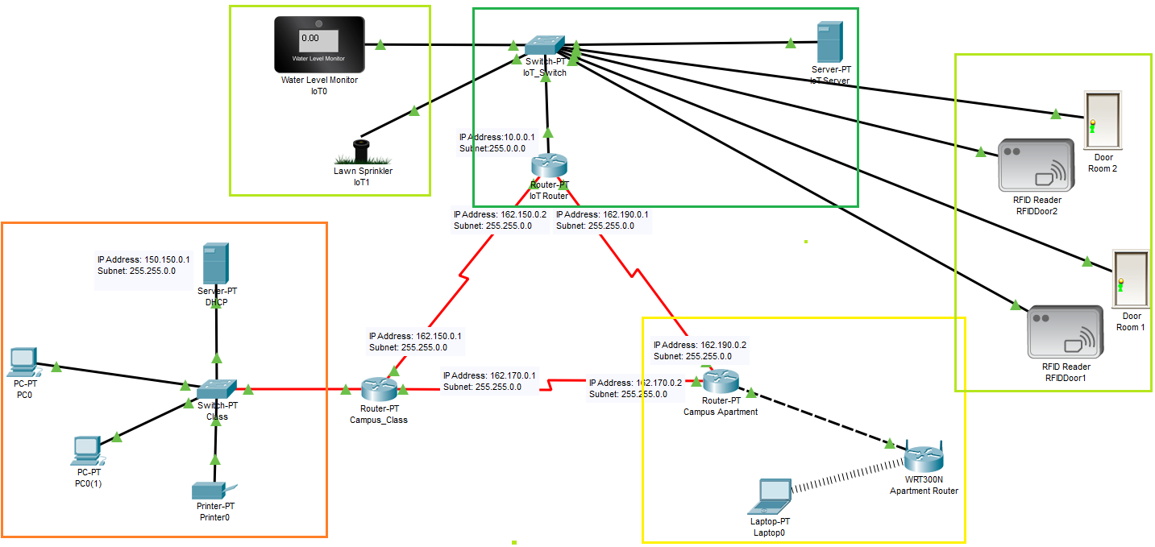

**Network Layout**

The network layout in this exercise is more complex compared to previous lab exercises. This network topology includes

* Backbone router network
* Traditional switch-based classroom wired network
* Wireless LAN for the apartment buildings
* Dedicated IoT network based also on switch

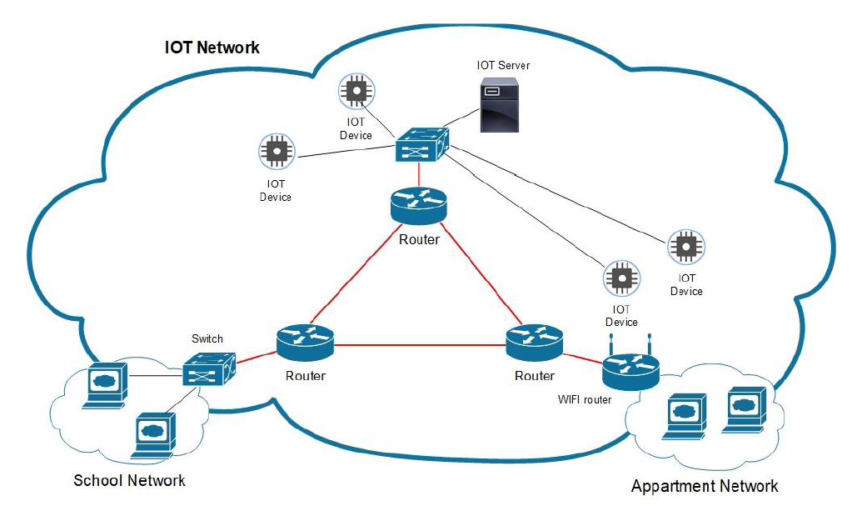

**Part 1: Backbone Router Network**

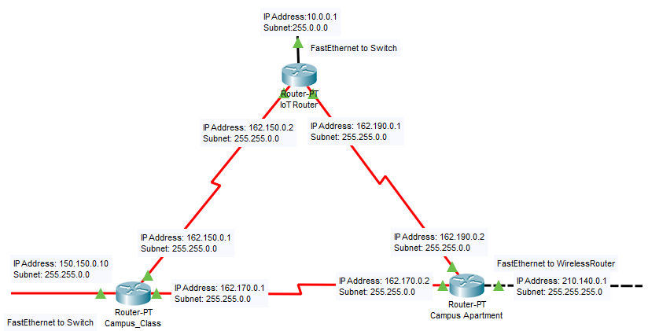

1. Set the router interface IP addresses as follows

|  |  |  |  |
| --- | --- | --- | --- |
| **Router Name** | **Interface** | **IP Address** | **Subnet** |
| Campus Class | FastEthernet to Switch | 150.150.0.10 | 255.255.0.0 |
| Serial 2/0 | 162.150.0.1 | 255.255.0.0 |
| Serial 3/0 | 162.170.0.1 | 255.255.0.0 |
| Campus Apartment | FastEthernet to Wireless Router | 210.140.0.1 | 255.255.0.0 |
| Serial 2/0 | 162.190.0.2 | 255.255.0.0 |
| Serial 3/0 | 162.170.0.2 | 255.255.0.0 |
| IoT Router | FastEthernet to Switch | 10.0.0.1 |  |
| Serial 2/0 | 162.150.0.2 | 255.255.0.0 |
| Serial 3/0 | 162.190.0.1 | 255.255.0.0 |

1. Implement **RIP Protocol** on all the three routers as shown below.

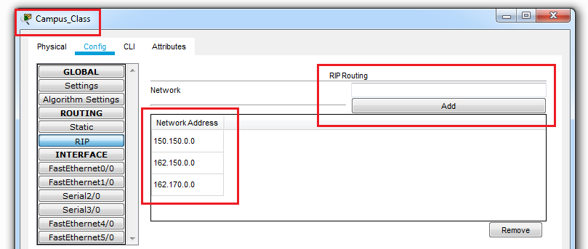

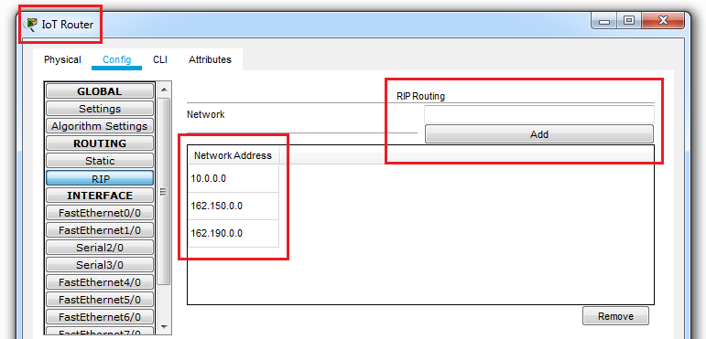

(Part 2 Below)

**Part 2: Setting up Campus Class Network**

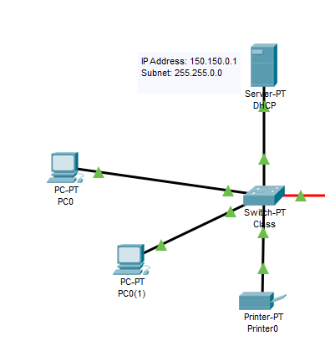

1. Add devices as shown in the above diagram.
2. Setup a **DHCP** server. A DHCP Server is a network server that automatically provides and assigns IP addresses, default gateways and other network parameters to client devices. Therefore one a DHCP server is configured, there is no need to add IP Addresses to the remaining client devices.

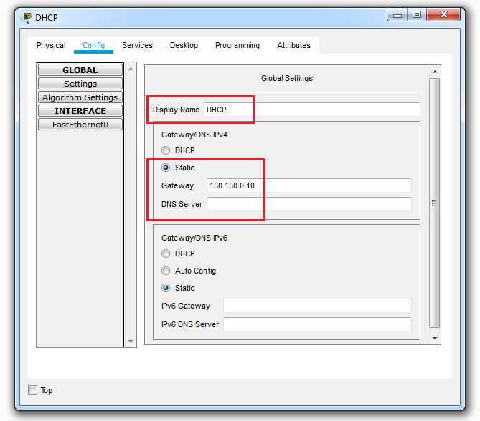

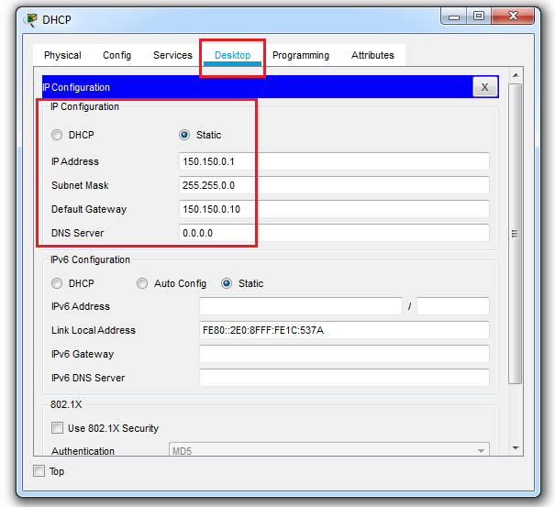

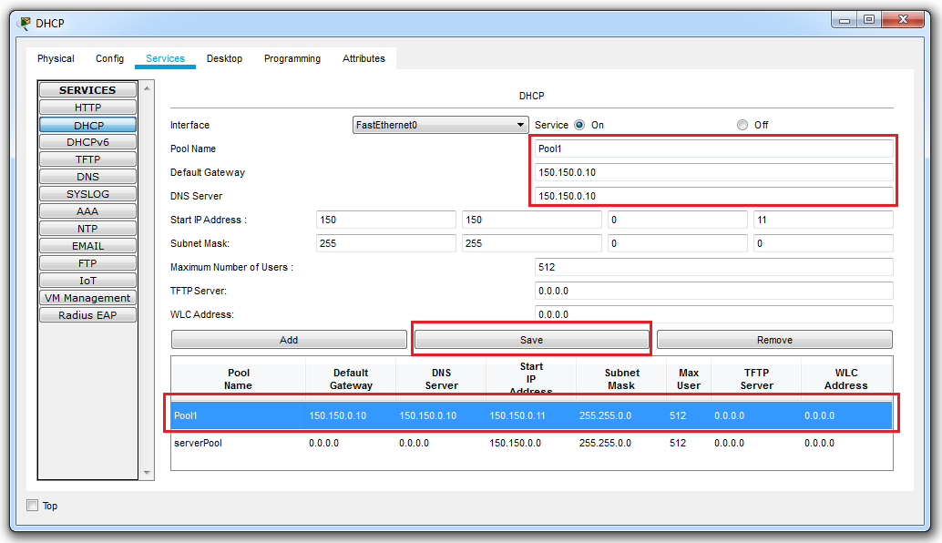

1. For all the devices, turn on the connected port and refresh the DHCP option. The port is allocated an IP address by the server.

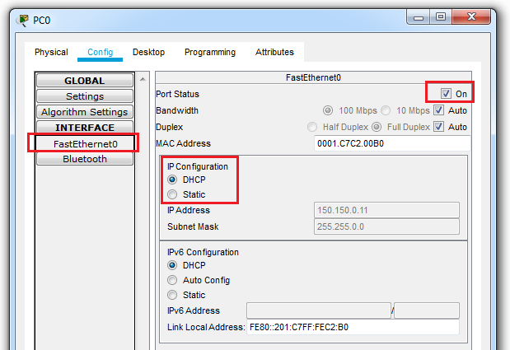

1. For all the devices, refresh the DHCP option in the Settings. The Gateway and DNS IP Address configured in the DHCP server will appear.

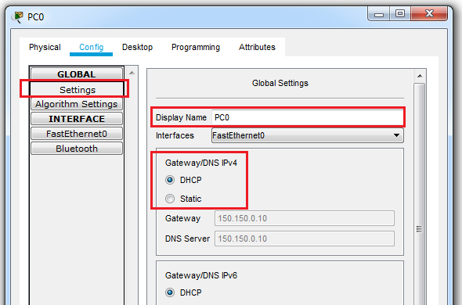

(Part 3 Below)

**Part 3: Setting up Campus Apartment Network**

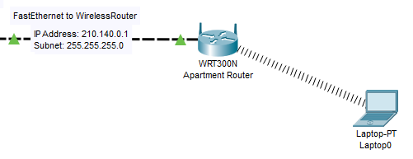

1. Setup the wireless router WRT300N as shown below. We setup a wireless network through which various devices can connect.

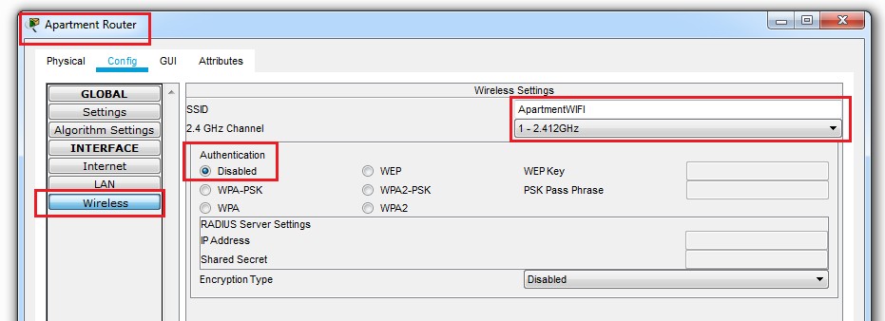

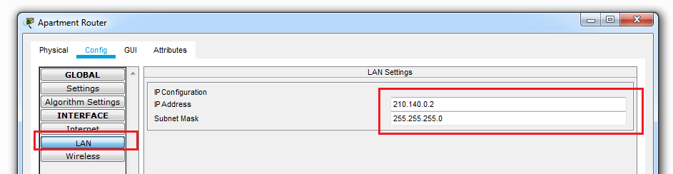

(Part 4 Below)

**Part 4: Setting up IoT Network**

We now setup the IoT network and add IoT devices. Before we add the devices as shown below.

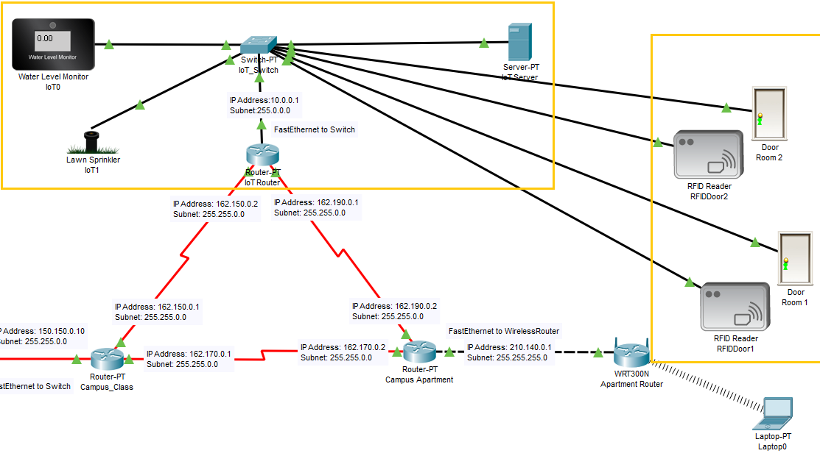

However, you will find that the switch does not have enough FastEthernet port to connect all devices. Therefore we add the ports to the switch as follows

1. Shut down the switch. Drag the PT-SWITCH-NM-1CFE to the empty slots on the right side of diagram.

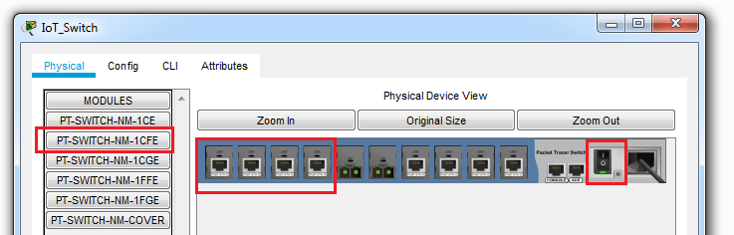

1. Make sure the IoT devices have FastEthernet ports. If not use the Advanced button on every IoT device. That will provide an I/O Config option, where you can change the port connectivity type

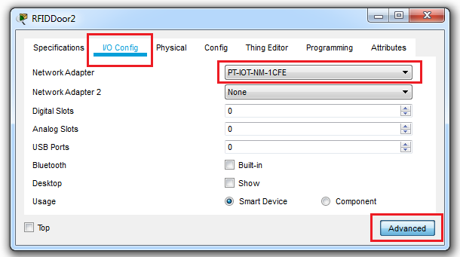

1. After adding all the devices and auto cabling them, we start with configuring the devices.
2. First we configure the IoT Server. Add IP Address to the IoT Server as shown below.

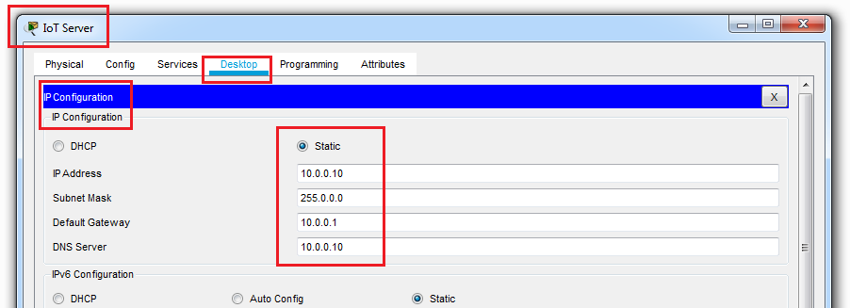

1. In Global Settings, configure the Name, Gateway IP and the DNS IP.

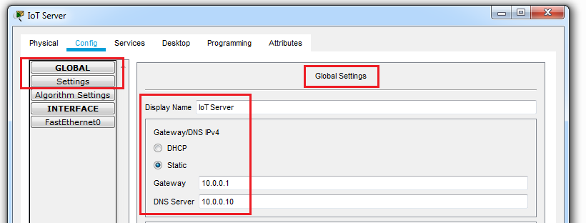

1. Add IoT Registration services as performed in previous labs

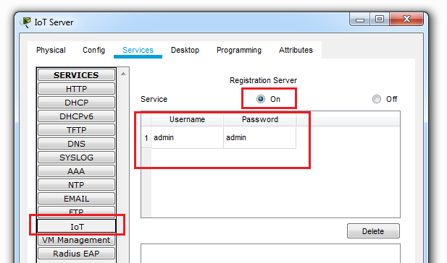

1. Add DNS services on the IoT Server

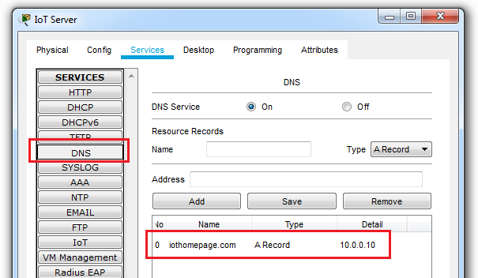

1. Add DHCP service on the IoT Server so it can assign IP addresses to IoT devices

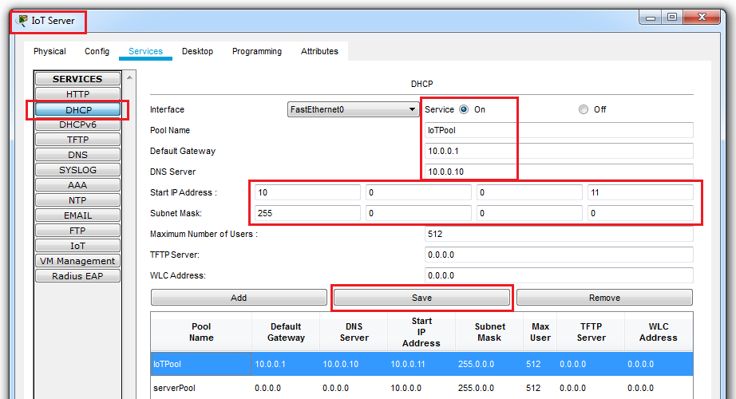

1. Configure all the remaining IoT Devices i.e. Door, RFID Readers, Lawn Sprinkler and Water Level Monitor with the following configurations.

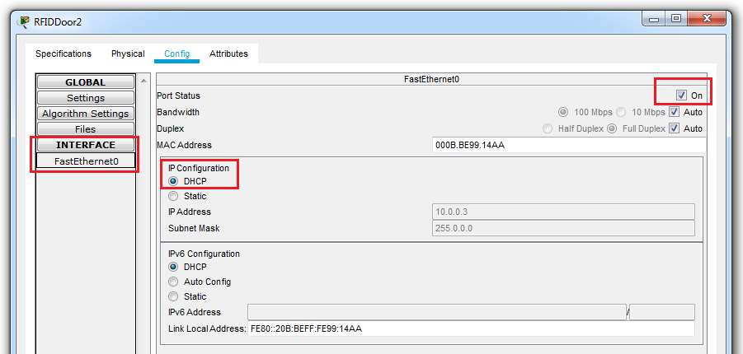

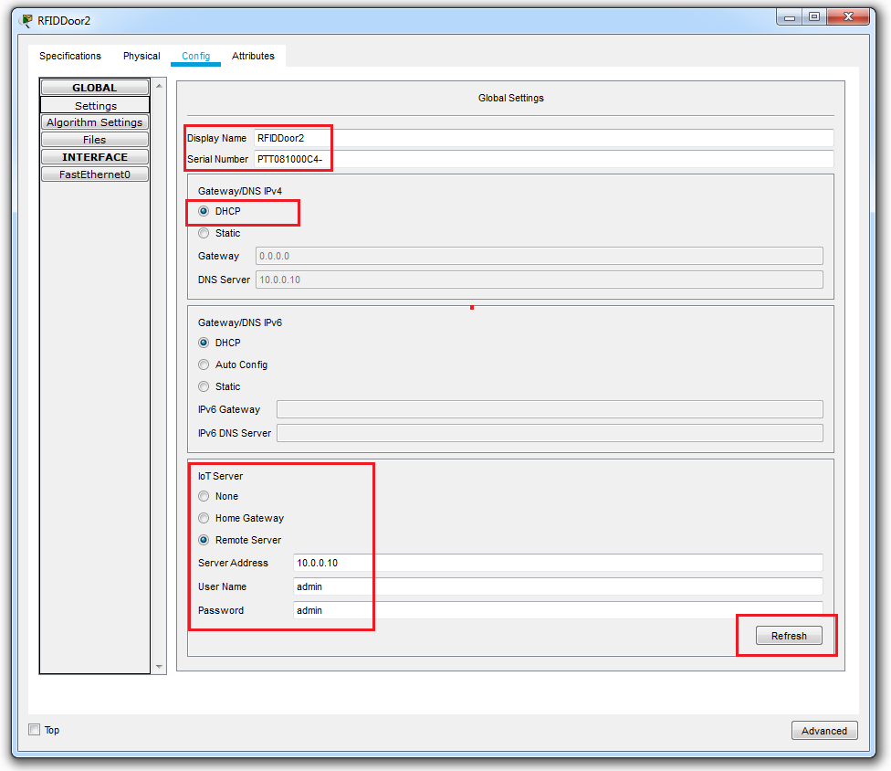

1. When all the devices are properly connected, the devices will show up in the IoT Registration Service. The Registration service can be accessible using the Web Browser and IP address 10.0.0.10

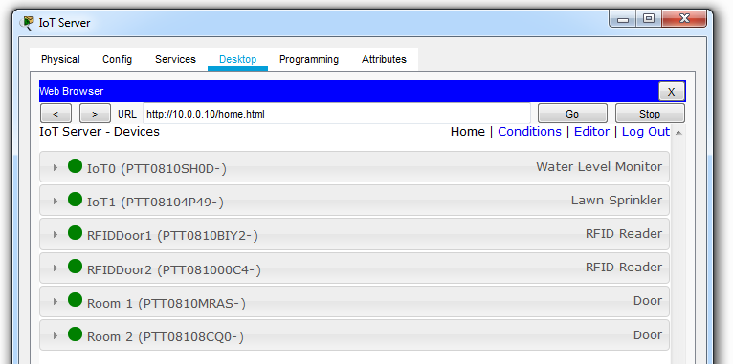

(Part 5 Below)

**Part 5: Adding IoT Device Conditions**

There are 2 ways to add IoT Conditions.

* Add a micro-controller, connect the devices and program the conditions
* Add the conditions in the IoT Registration Server.

We will use the second approach as we do not need to change the topology

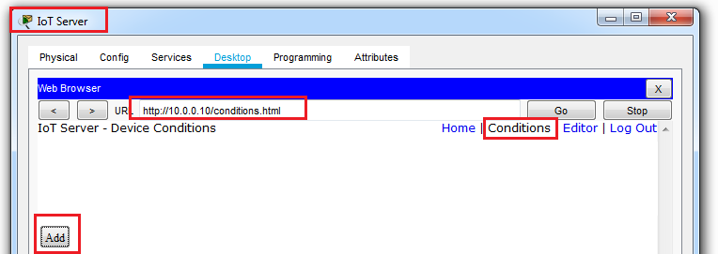

1. Add conditions for Lawn Sprinkler ON and OFF

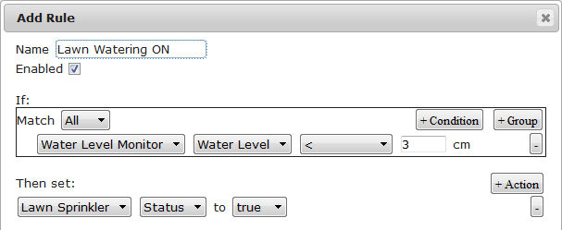

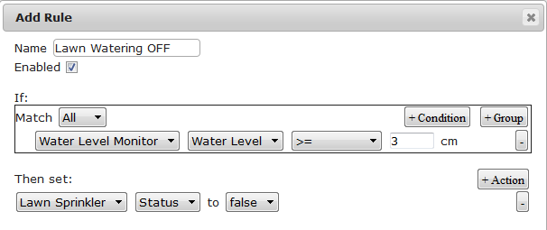

1. We now add RFID cards for the Apartment Doors

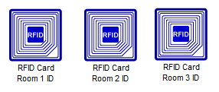

1. Configure the above RFID cards as follows

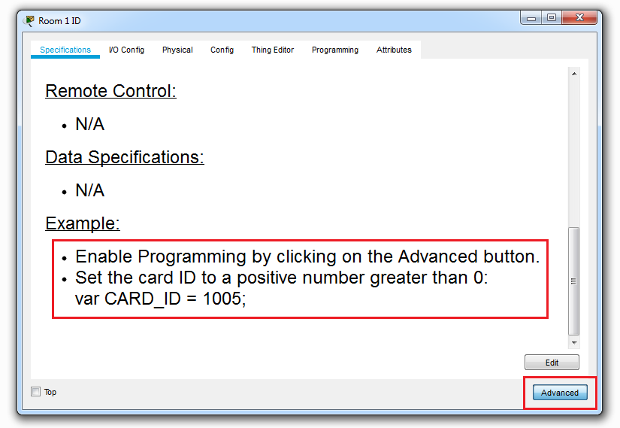

1. Select the Programming option and double click on RFID Card (Python)

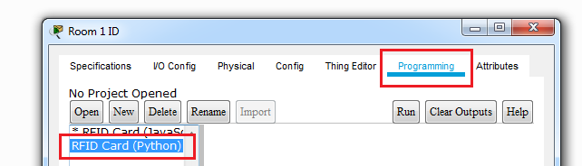

1. Double click on the main.py. And change the value of Card_ID to 01. Click Run. Similarly add 02 and 03 to RFID Card 2 and 3 respectively.

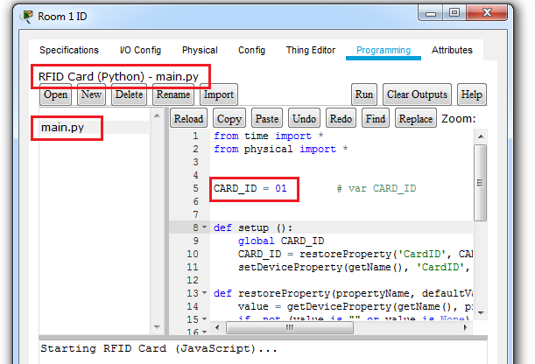

1. We now configure the RFID Reader. Add the following conditions in the Condition section in the IoT Registration Service website. Perform the following for all the RFID readers
   1. We first set all the RFID into a waiting mode and set room doors to lock status

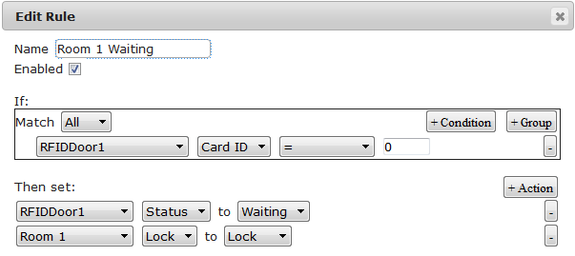

* 1. We set the unlocking conditions for the door

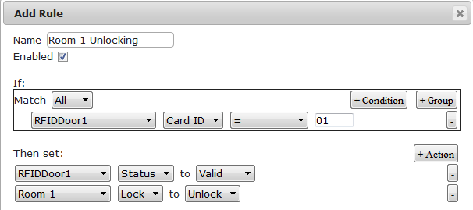

* 1. We set the locking conditions for the door

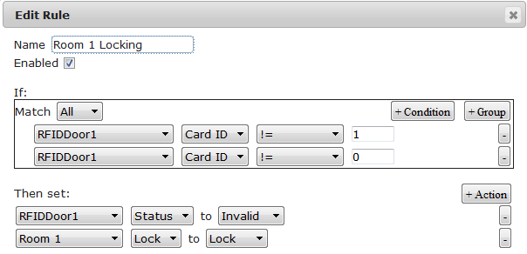

1. The door will unlock with proper RFID Card

